Parkinson’s stem cell therapy OK’d for testing

By Bradley J. Fikes | 5:30 a.m. Dec. 14, 2015

Unfertilized human egg cells source of replacement neurons

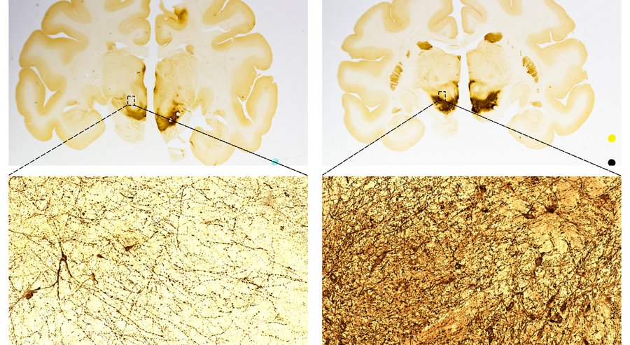
In what appears to be a medical first, a stem cell-based treatment for the root cause of Parkinson’s disease has been accepted for human testing.
The Australian government’s approval for Carlsbad-based International Stem Cell Corp., or ISCO, also represents a milestone in the company’s quest to develop its own kind of stem cells for therapy.
If all goes according to plan, doctors will implant replacement brain cells into 12 Parkinson’s patients, probably in the first quarter of 2016, said Russell Kern, the company’s chief scientific officer. These are called neural precursor cells, a slightly immature kind of neuron. The cells will finish maturing in the brain into the kind of neurons destroyed by the movement disorder.
The neural precursor cells are derived from the company’s parthenogenetic stem cells, which are produced from unfertilized human egg cells.
The Australian government gave its clearance last week. One more approval is required by a review board at The Royal Melbourne Hospital, where the clinical trial will take place. Kern said the company chose to test in Australia because that nation’s clinical trial system is more “interactive,” which allows for better collaboration with Australia’s Therapeutic Goods Administration on trial design.
Russell Kern, chief scientific officer of International Stem Cell Corp.— International Stem Cell Corp.
This will be the first Parkinson’s trial using replacement brain cells grown from stem cells, according to the clinical trial tracking site clinicaltrials.gov. The test will be conducted by ISCO’s Australian subsidiary, Cyto Therapeutics.
The treatment aims to directly fix the root cause of the disease — a loss of neurons that make dopamine. This loss causes Parkinson’s patients to experience tremors, stiffness and slowing of movement. Speech may also become slurred and swallowing difficult, possibly causing the person to choke. If this therapy is proven safe and effective in restoring normal movement, it would be the first of its kind.
The approach raises the possibility of a cure for Parkinson’s, or at least an extended time of relief from its symptoms. Success would also be good news for attempts to use stem cells to treat other diseases that cause degeneration of the brain, including Lou Gehrig’s disease, or ALS.
Publicly traded ISCO has been developing its parthenogenetic technology for many years on shoestring financing, with a market valuation to match. As of the close of trading Friday, the company’s total market value amounted to just $11.1 million.
The company’s scientists have published well-regarded research. But even if the technology works well, there’s still plenty of competition from other types of stem cells.
Parthenogenetic cells act much like embryonic stem cells. They’re valued for their quality of pluripotency — the ability to turn into nearly any kind of cell in the body.
But many people who oppose abortion find the use of embryonic stem cells to be ethically objectionable, because getting the cells requires killing embryos. ISCO said its cells remove that objection, since no embryos are killed in its process.
Parthenogenetic stem cells aren’t used as widely as embryonic stem cells or another type called induced pluripotent stem cells, which also mimic embryonic stem cells. Induced pluripotent stem cells can be grown from skin cells, which also avoids the abortion issue.
In addition, “adult” stem cells are being tested for a variety of diseases, including Parkinson’s. This category of cells includes mesenchymal stem cells, which appear to have regenerative properties throughout the body. One proposed clinical trial in Indonesia planned to use these cells to grow replacement brain cells, but it couldn’t recruit enough patients.
And La Jolla’s StemGenex is recruiting Parkinson’s patients for a clinical trial of stem cells isolated from the patients’ own fat tissue, called stromal vascular fraction stem cells.
Many other attempts at stem cell therapy for neurodegenerative diseases are offered at stem cell clinics that don’t go through a country’s government-approved clinical trial process.
Another strategy
The ISCO approach to Parkinson’s is much the same as that of a San Diego group called Summit for Stem Cell, which uses induced pluripotent stem cells. That nonprofit is raising money for a clinical trial.
While ISCO is deriving its replacement neurons from unfertilized egg cells, Summit for Stem Cell is producing them from the patients themselves.
Both groups intend to transplant the cells while they are still slightly immature, so they can finish their development in the brain. Animal studies suggest this method is best for producing cells with the desired functions. Some of these neural stem cells turn into the dopamine-making neurons while others remain as neural stem cells, sustaining those making dopamine, Kern said.
“It’s a dual action,” Kern said. “Also, neural stem cells reduce inflammation, and inflammation is huge in Parkinson’s.”
That’s also the approach Summit for Stem Cell will take, said stem cell scientist Jeanne Loring, a leader of the Summit 4 Stem Cell project. The cells make proper connections with the brain better when they are still maturing, said Loring, who’s also head of the regenerative medicine program at The Scripps Research Institute in La Jolla.
That’s assuming the project can secure the millions of dollars needed and get the required approvals from the U.S. Food and Drug Administration.
Loring said she views ISCO as a partner in fighting Parkinson’s. One of her former students is working for the company, she said.
“The whole idea is to treat patients by whatever means possible,” Loring said.
Precedent
ISCO’s choice of Australia for its streamlined regulatory process makes sense, Loring said. Her team, with U.S.-based academics and medical professionals, doesn’t have the same flexibility as ISCO in looking for clinical trial locations, she said.
There is a limited precedent for these treatments.
Transplants of fetal brain cells into a small number of Parkinson’s patients were performed a few decades ago. Some of those patients experienced relief, while others didn’t benefit or developed uncontrollable movements.
These problems may have arisen from the variable quality of the fetal cells, Loring said. In some cases, cells from multiple fetuses were used to get enough material for a transplant.
Loring said it’s hoped that transplants of cells from a single source, carefully controlled for quality, will yield a better result.

